**The files in this C:/LongGiaPha are displayed by the render.com web site by *typing on the browser URL bar* “longgiapha51.xyz” or “longgiapha-9jlj.onrender.com” (provided by** [**www.render.com**](http://www.render.com) **when setting up my account)**

The above command will run index.html in the github repository “longgiapha51/LongGiaPha”. In index.html giaphabenngoai.pdf will be executed and show the main page of our family tree. **Note** that the absolute path is <https://longgiapha51.xyz>. In Word hyperlink this path must be specified for the pdf file to be linked to, say “*https://longgiapha51.xyz/giaphabasohai.pdf*”

**C:/LongGiaPha files are maintained on GitHubby the Git Bash application (DOS)**

To maintain the longgiapha files:

**1.** Edit the word file/s in E:/LongGiaPha Edit/Docx. If there is a hyperlink the linked pdf file path must have an absolute path <https://longgiapha51.xyz/> (eg [*https://longgiapha51.xyz/giaphabasohai.pdf*](https://longgiapha51.xyz/giaphabasohai.pdf)”). The word file is saved 2 times: one as word itself in E:/LongGiaPha Edit/Docx; the other is as a pdf file in in E:/LongGiaPha Edit. For hyperlink see “**Hyperlink to another in word.docx**” in E:/LogGiaPha.

**2.** Copy the edited pdf file/s and its hyperlink pdf file/s if any, to C:/LongGiaPha.

**3.** Run Git Bash from your PC:

**1.** In the Window box type **Git Bash** to run the app.

**2.** **cd C:/longgiapha** to get to longgiapha under C:/

**3. git status**: show its status with **red files**.

**4. git add .** : add those modified file/s and new files if any (see comments on the screen). To ensure they have been added, run git status again. All files are now **green** (up-to-date).

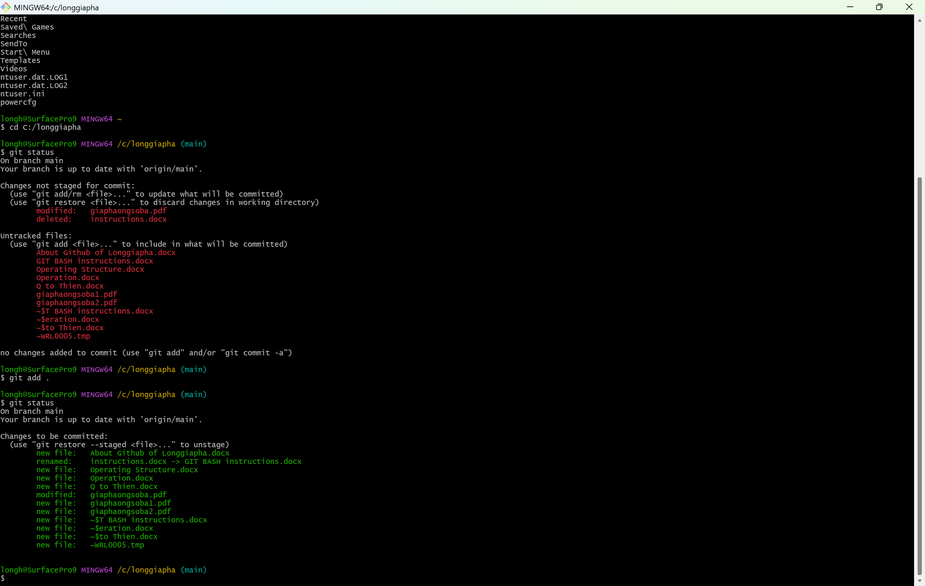

**5. git commit -m “mod 121224**” (mod 121224 as a note to be shown on git hub). Now committed files are shown as “**white**”.

**6.** Finally run “**git push -u origin main**” to upload onto git hub. If running git status again it shows empty C:/longgiapha.

**7.** Go to web run longgiapha51.xyz on the URL bar to check the updates.

To copy all files in my github repository to another PC for maintenance:

1. Sign in to github (<http://github.com>). Click longgiapha51/LongGiaPha repository.

1. Click <> Code to use the Clone command to download all files in our github to another PC. Then download the Git Bash app to maintain (edit, upload) files in the local PC to github.

